**first import ‘useState’ from ‘react’ and then use it ↓**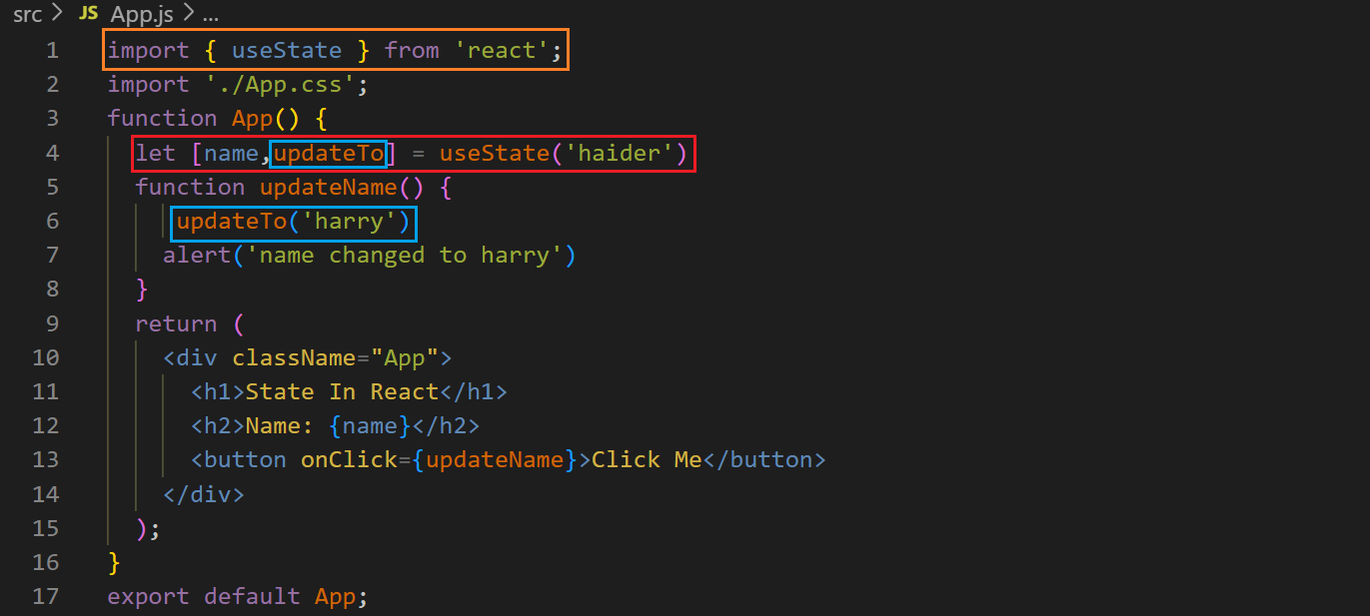

**on using variable, the code does not re-render, i.e., the code is not executed again therefore the variable is updated but does not show, so we use state. On using state the code is executed again.**

**Before clicking the button ↓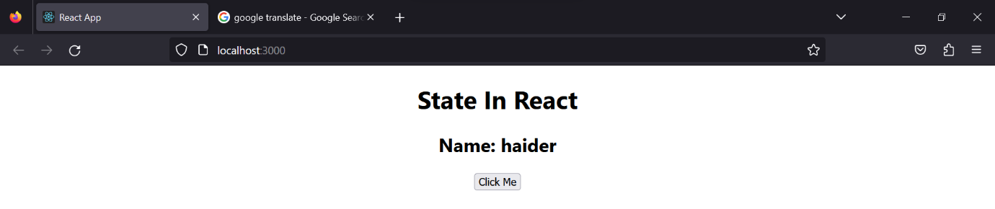After clicking the button ↓**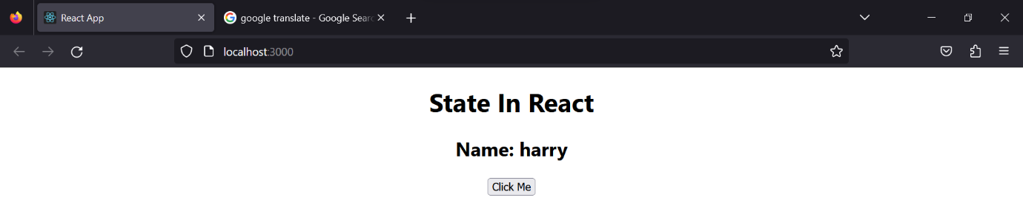

**We can use it for another purposes, e.g., ↓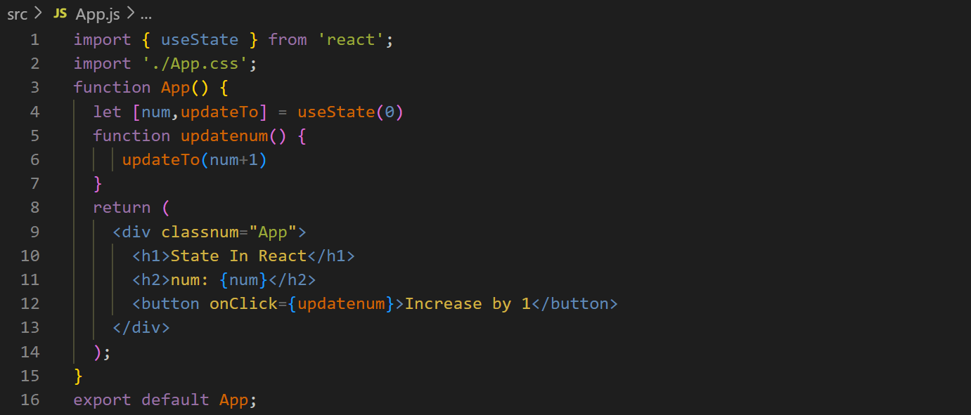on every click the number will increase by 1, e.g., after clicking 10 times ↓**